Table contents

|  |  |
| --- | --- |
| CONTENTS | PAGE NO |
| 1. **Introduction** | 2 |
| * 1. purpose | 3 |
| * 1. scope | 3 |
| * 1. objectives | 3 |
| 1. **Functional requirements** | 4 |
| * 1. primary actors of the system | 4 |
| * 1. use case diagram | 5-7 |
| * 1. user stories | 8 |
| * 1. business process diagram | 8-9 |
| 1. **Non-functional requirements** | 10 |
| 1. **Technical requirements** | 11 |
| 1. **Conclusion** | 11 |

Job portal

Software requirements and specifications (SRS)

1. INTRODUCTION

The Job Portal System is a dynamic web-based application designed to serve as a pivotal bridge between job seekers and employers. This innovative platform empowers individuals in their quest for employment opportunities and equips organizations with the tools needed to identify, evaluate, and hire the most suitable candidates.

The importance of clearly defining system requirements in the development and implementation of a job portal system cannot be overstated.

1. Alignment with Stakeholder Needs: Clearly defined requirements ensure that the system is built to meet the specific needs and expectations of both job seekers and employers. This alignment is crucial to the system's success as it directly affects user satisfaction.
2. Efficient Development: Well-defined requirements provide a roadmap for developers, enabling them to efficiently create the system. It helps in avoiding costly rework and changes later in the development process.
3. Functionality and User Experience: A thorough understanding of requirements ensures that the system's functionalities are well-designed, and the user experience is optimized. This, in turn, enhances user engagement and adoption.
4. Cost Control: Detailed requirements help in estimating the project's budget accurately. It allows for better cost control throughout the development process, preventing unexpected expenses.
5. Timely Delivery: With clear requirements in place, development and implementation timelines are more predictable. This is crucial for meeting project deadlines and going to market sooner.
6. Quality Assurance: Well-defined requirements serve as a foundation for effective testing and quality assurance processes. They help in identifying and rectifying issues early in the development cycle, leading to a more robust and reliable system.
7. Scalability and Future-Proofing: Understanding the long-term needs and scalability requirements ensures that the system can adapt to changing market conditions and technology advancements.
8. Regulatory Compliance: If there are specific legal or regulatory requirements that the job portal system must agree to, clearly defining these requirements is crucial to avoid legal issues.

In conclusion, the success of a job portal system depends on how well its requirements are defined. Thoroughly understanding the needs of stakeholders, creating a detailed requirement specification, and continuously validating and updating these requirements throughout the development process are key steps to ensure the system's successful development and implementation. It's a critical foundation for a user-friendly, efficient, and effective job portal system that serves both job seekers and employers.

* 1. PURPOSE

The purpose of the SRS document for the job portal system.

Contractual Agreement: It is a contract between the client and the development team. It describes the characteristics and functions that will be provided by the system as agreed upon.

Documentation for Future Reference: It acts as a valuable reference document throughout the project's lifecycle. It can also be used for improve the employment portal system in the future

Requirements Clarification: The SRS document clarifies the expectations and needs of client involved in the development.

SRS document provides developers with a clear and detailed roadmap for designing, coding, and testing the software.

The functional requirement includes the use cases, features, and user stories of the admin module. The non-functional requirement includes as performance, reliability, security, usability, etc.

The main purpose is to identifying, and understanding what the job portal system and satisfy the needs of client, It helps to understand the client what the developers are going to do. For the development team SRS is like a route-map. It provides the detailed instruction on what feature they want to work and how they want to work.

* 1. SCOPE

The Job Portal System will include the following features:

* Job Seeker Module: Registration, profile management, job search, application submission, and job recommendations.
* Employer Module: Registration, job posting, applicant management, and messaging.
* Admin Module: User management, content moderation, and reporting.
* System notifications and alerts.
* Data analytics for employers.
* User support and FAQs.
  1. OBJECTIVE

the high-level objectives of job portal system are as follows:

* Efficient Job Matching: Connect job seekers with relevant job opportunities.
* Streamlined Recruitment: Help employers efficiently manage job listings and applicants.
* Effective System Management: Provide administrators with tools for efficient system management.
* Enhanced User Experience: Create a user-friendly environment for job seekers and employers.

The system aims to address the following goals and problems:

* Simplify job searches for job seekers.
* Make applicant management easier for employers.
* Ensure user data is secure and private.
* Provide employers with data-driven insights.
* Create an easy-to-use platform.
* Define system limitations to manage expectations.
* Ensure easy system upkeep and updates.

1. FUNCTIONAL REQUIREMENTS
   1. PRIMARY ACTORS

* Job seekers
* Job providers
* Platform admin
  1. USE CASE DIAGRAMS

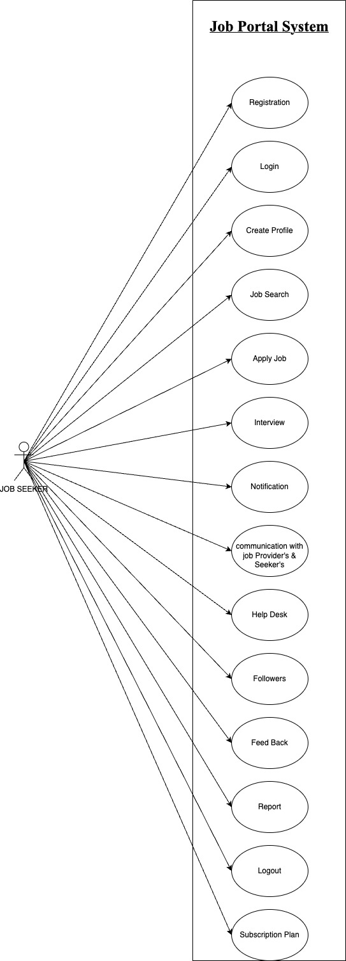JOB SEEKER

JOB PROVIDER

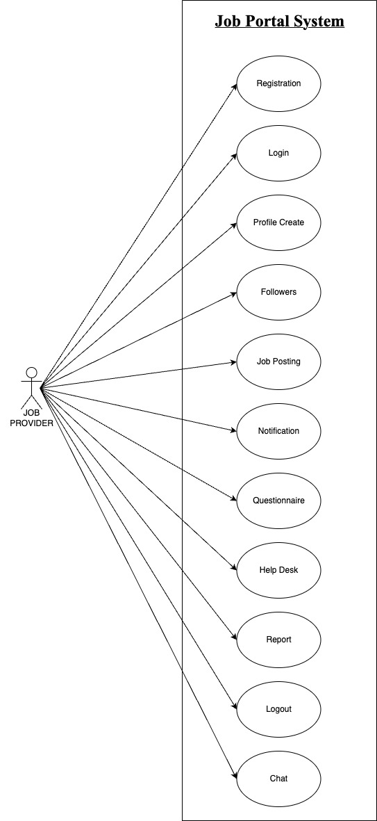

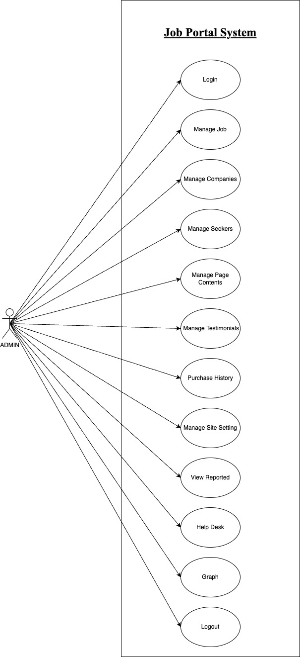PLATFORM ADMIN

|  |  |  |
| --- | --- | --- |
| As A [type of user] | I NEED TO [do some task] | SO THAT I CAN [get some result] |
| Job seeker | Login to the app as I registered | Enter my username & password to access my account |
| Job provider | Post a job on the job portal | Advertise job openings and attract employees |
| Platform Admin | Approve job providers before they can post job listings on the platform | Ensure the quality of job listings on the platform and prevent fake job posting |

* 1. USER STORIES
  2. BUSINESS PROCESS DIAGRAM

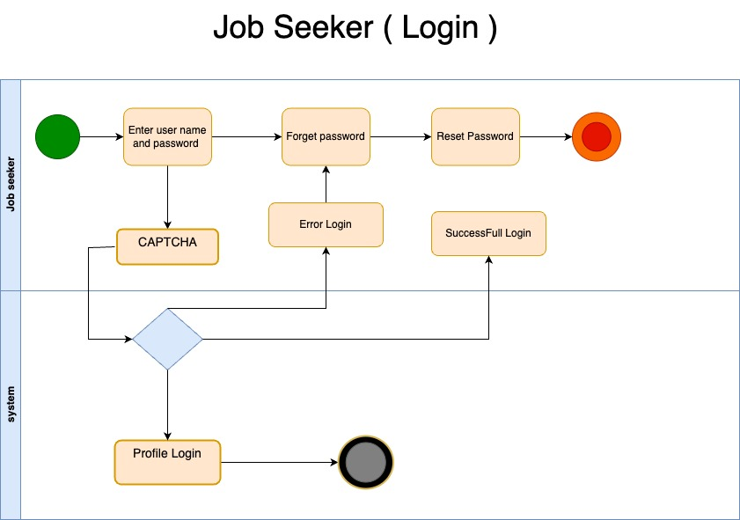

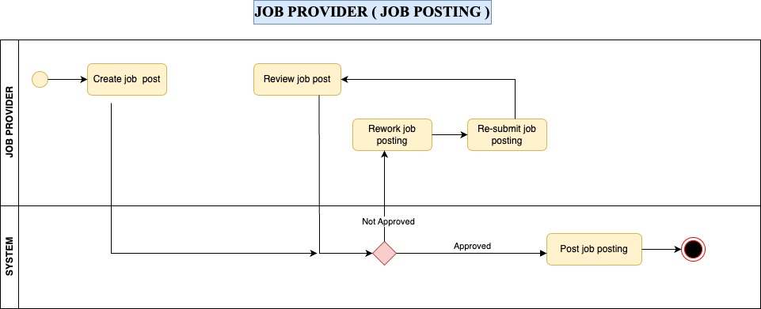



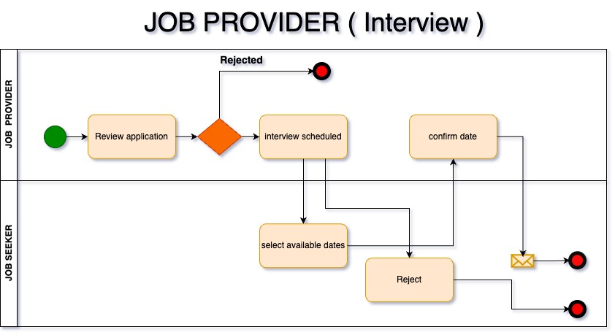

1. NON-FUNCTIONAL REQUIREMENTS

the non-functional requirements for the Job Portal System

Performance:

* Response time for user actions: Should be under 3 seconds.
* Throughput: Support a minimum of 100 job applications per minute during peak times.
* Availability: System should be available 24/7 with scheduled maintenance kept to a minimum.

Reliability:

* Uptime: Maintain at least 99% uptime per year.
* Error handling: Provide clear error messages and recover gracefully from errors.
* Data backup: Conduct automated data backups regularly.

Security:

* User authentication: Ensure strong user authentication and password policies.
* Data encryption: Sensitive data must be encrypted.
* Access control: Implement role-based access control to restrict unauthorized actions.
* Protection against common vulnerabilities like SQL injection and XSS.
* User privacy: Strictly enforce privacy policies and data protection regulations.

Usability:

* User interface design: Create an intuitive, user-friendly design that's accessible on various devices.
* Mobile responsiveness: Ensure a mobile-friendly experience.
* Help and documentation: Provide clear help resources for users.

Scalability:

* Load balancing: Implement load balancing for even system load distribution.
* Database scalability: Database must scale with increased data volume.

Compatibility:

* Browser compatibility: Support common web browsers like Chrome, Firefox, and Safari.
* OS compatibility: Ensure compatibility with various operating systems.

Regulatory compliance:

* Legal compliance: Abide by relevant legal regulations concerning job listings and data protection.

Auditability:

* Activity logs: Maintain detailed logs of system activities for auditing.

These non-functional requirements define the performance, reliability, security, usability, and compliance standards that the Job Portal System needs to meet.

1. TECHNICAL REQUIREMENTS

* **Software Stack**: The system will use a technology stack comprising HTML5, CSS3, JavaScript, React.js for the front-end, Node.js, Express.js for the back-end, and MySQL for the database.
* **Hosting**: The system will be hosted on an AWS infrastructure.
* **Compatibility**: The system will be compatible with major web browsers (e.g., Chrome, Firefox, Safari) and responsive on various devices (desktop, tablet, mobile).

1. CONCLUSION

In conclusion, the Job Portal System SRS outlines the objectives, functional and non-functional requirements, user stories, and technical requirements of the system. This document serves as a blueprint for the development team, ensuring that the system meets its objectives and addresses the identified goals and problems effectively. It sets the foundation for creating a user-friendly, secure, and efficient platform for job seekers and job providers.